|  |  |  |  |  |  |  |  |
| --- | --- | --- | --- | --- | --- | --- | --- |
|  | 3. TRIGGERS    Seeing others install virtual eye on their  swimming pools |  | TR | 10. YOUR SOLUTION SL we make use of one camera that streams the video underwater and analyses the position of swimmers to assess the probability of drowning | 1. CHANNELS of BEHAVIOUR    1. ONLINE   Ordering of drowning detectors, or pool lifeguards   * 1. OFFLINE | CH |  |

Project Title: VirtualEye - Life Guard for Swimming Pools to Detect Active Drowning Project Design Phase-I - Solution Fit Template Team ID: PNT2022TMID41118

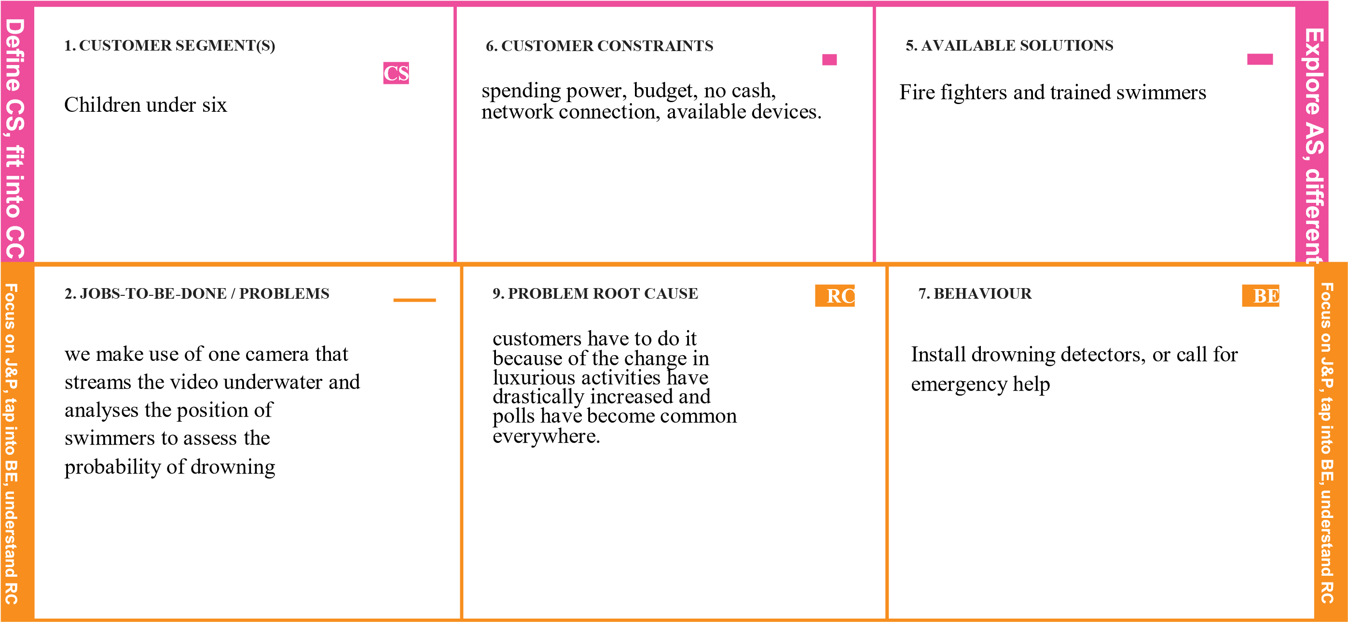

|  |  |  |  |  |
| --- | --- | --- | --- | --- |
|  | 4. EMOTIONS: BEFORE / AFTER  EM  Lost and insecure/confident and in control |  | Implementing them to wear them without fail |  |